

**Government of Saint Lucia**

**Medium Term Debt Management Strategy**

**For the period 2013/14-2017/18**

**Prepared by the Debt and Investment Unit**

**Office of the Director of Finance**

**Department of Finance, Economic Affairs & Social Security**

**January 2014**

**TABLE OF CONTENTS**

ForeWORD………………………………………………………………………………… 3

acronyms……………………………………………………………………………………..4

Executive Summary…………………………………………………………………....5-6

SECTION 1: INTRODUCTION……………………………………………………………7-8

SECTION 2: DEBT MANAGEMENT OBJECTIVES……………………………….……..9

SECTION 3: LEGAL AND INSTITUTIONAL FRAMEWORK…………………………..10-11

section 4: Review of past debt strategy 2008-2012………………………..12

SECTION 5: REVIEW OF DEBT PORTFOLIO 2012/2013………………………..…13-18

SECTION 6: MARCOECONOMIC OVERVIEW……………………..........………....19-21

SECTION 7: MEDIUM TERM DEBT MANAGEMENT STRATEGY (MTDS)……..22-28

SECTION 8 IMPLEMENTATION METHODOLOGY……………………………....29-30

SECTION 9: TRANSPARENCY AND ACCOUNTABILITY…………………….……..31

SECTION 10: ACKNOWLEDGEMENT……………………………………...….…………32

section 11: GLOSSARY……………………………………………………………......33-35

APPENDICES: ………………………………………………………………………….....36-39

# FOREWORD

This publication represents the first Medium Term Debt Management Strategy (MTDS) utilizing the framework developed by the International Monetary Fund and the World Bank. Public borrowing and the level of public debt have been consistent with the overall fiscal framework aimed at ensuring macro-economic stability over the medium term. This MTDS is expected to inform borrowing in the short to medium term commencing 2013/2014 to 2017/2018.

The objective of the MTDS is to analyze the cost and risk inherent within the portfolio, referencing the interest rate risk, refinancing risk and foreign exchange risk. In keeping with this objective the public debt is categorized on the basis of currency underlying the foreign exchange risk within the portfolio. Therefore references to external and domestic debt relate to foreign currency and local currency debt respectively. However, this is a departure from the usual practice of presenting external and domestic debt based on residency.

The 2013/14 MTDS will be tabled in Parliament in 2014 to guide borrowing in the financial year 2013/14. The MTDS tool evaluates the costs and risks of various scenarios to reach an optimal strategy that is implemented in the course of the year. It is envisioned that the document will form a central tool of the operations of the Department of Finance, particularly the Debt and Investment Unit (DIU), as it seeks to source financing for the implementation of Government’s policy decisions.

As we embark on implementing the MTDS it is important that the burden of public borrowing is equitably shared between present and future generations. In putting forth this strategy, the Government aims to apply international best practice to its management of public finances. Looking ahead, it is expected that the GOSL’s fiscal strategies will be guided by the principles of public finance to ensure that public debt remains within sustainable levels aiming for the threshold of 60.0 percent of GDP set by the Monetary Council of the Eastern Caribbean Central Bank.

**Honourable Dr. Kenny D. Anthony**

**Prime Minister and Minister for Finance, Economic Affairs, Planning & Social Security**

# ACRONYMS

ABP Annual Borrowing Plan

ATM Average Term to Maturity

ATR Average Time to Re-fixing

CS-DRMS Commonwealth Debt Recording and Management System

CDB Caribbean Development Bank

DOD Debt Outstanding and Disbursed

DMAS Debt Management Advisory Service

DMU Debt Management Unit

ECCB Eastern Caribbean Central Bank

EC Eastern Caribbean Dollars

FX Foreign Exchange

GDP Gross Domestic Product

GOSL Government of St. Lucia

IBRD International Bank for reconstruction and Development

IDA International Development Association

IMF International Monetary Fund

KWD Kuwait Fund for Arab Economic Development

MTDS Medium Term Debt Strategy

PV Present Value

RGSM Regional Government Securities Market

SFR Special Funds Resources

USD United States Dollars

VAT Value Added Tax

**EXECUTIVE SUMMARY**

This publication is the first Medium Term Debt Management Strategy (MTDS FY2014- 2018) of the Government of Saint Lucia covering financial years FY2013/14 to FY2017/18. This strategy document comes against a background of adverse economic and financial development on the ECCU including Saint Lucia. The management of the debt programme involves the design and implementation of debt strategies which will effectively align the debt level with fiscal sustainability and to achieve the Monetary Council’s public sector debt to GDP target of 60.0 percent by the year 2020.

The GOSL’s current debt burden has fostered the inability of the government to accumulate buffers and to implement fiscal policies to spur economic growth needed and to place the country on a more sustainable path. The current debt portfolio has been characterized by short term domestic debt creating significant pressure on cashflows and fostering high rollover risks. Consequently, the 2013 MTDS envisages a continued reliance on the domestic market and commercial borrowing to meet most of the gross financing needs by the year FY2017/18, with target on longer term instruments of about 10 years duration. This strategy will facilitate the need to reduce rollover risk as well as provide the government with more time to meet the requirements necessary to access more external concessional funding.

Of the four strategies which were developed to examine the cost and risk scenarios, the strategy which best meets the objective of reduced rollover risk and reliance on short term domestic instruments is strategy 4 (S4). Strategy four offers minimum reliance on short term instruments of treasury bills with a term of one year, and allows for an average time to maturity of 7.7 years from 5.7 years under the existing strategy, as well as an average time to refixing (ATR) of 7.3 years compared to 5 years currently. Strategy one (S1) depicts the current scenario of the government, Strategy two (S2) aims to reduce the cost of debt through greater concessional funding and Strategy three (S3) seeks to reduce short term borrowing to minimise rollover risk and lengthen maturity by issuing bonds on the RGSM.

In keeping with the government’s debt management objectives of raising an adequate level of financing at minimum costs with prudent levels of risk, the interest to GDP ratio is significant and S2 presents the lowest cost but highest risk for the interest/GDP ratio. In terms of Debt to GDP, while S2 presented the lowest ratio of 84.2 percent and S4 showed the highest ratio of 86.4 percent by 2017/2018, S2 would be most inclined to high levels of interest and exchange rate shocks because of its higher dependence on variable interest rate longer term instruments of 15 years. It is believed that Strategy four will be most effective to mitigate the roll-over risk which is currently faced under the S1 scenario and to reduce the heavily reliance on the domestic market.

The Annual Borrowing Plan of the Government is a necessary part of the implementation of the strategy, and as such will be used alongside the Estimates of Expenditure and Revenue for the respective years covered by the strategy document. From the FY 2013/2014, the annual borrowing plan of $697 million under S4 will require 44 percent or $309.30 million from external financing and 56 percent or $388 million domestic financing.

In the short term under the baseline scenario the fiscal position of the central government will experience continued decline in the overall balance driven by an expansion in current expenditure which will offset increases in current revenue. In light of this and the slow global economic recovery, the government will need to bridge the gaps through greater monitoring of its debt portfolio and fiscal consolidation measures.

Going forward, the DIU in collaboration with the Research and Policy Unit and ECCB DMAS will engage in regular updates and reviews of the MTDS according to the existing market conditions and the objectives of the selected strategy. Those annual revisions will be submitted to Cabinet to assist with the annual budget preparation

# SECTION 1

# INTRODUCTION

In response to the adverse impact of the global economic and financial crisis on the economies of the ECCU, the Monetary Council articulated a comprehensive Eight Point Stabilisation and Growth Programme, designed to stabilise these economies and ultimately steer them towards a path of sustainable economic growth and development. In line with the Eight Point Stabilisation and Growth Programme, the authorities identified the period 2012 to 2014 as one of stabilisation and adjustment, while 2015 to 2020 would transition into a time of transformation and growth. The third of the Eight Point Plan requires countries to establish an effective debt management programme that would bring their debt levels to a sustainable position. Inter alia, the debt management programme involves the design and implementation of debt strategies, which will effectively align these countries’ debt to a level that is consistent with fiscal sustainability and the achievement of the Monetary Council’s public sector debt to GDP target of 60.0 per cent by the year 2020.

The substantial debt burden of the ECCU countries renders them vulnerable to exogenous shocks and curtails the ability of these governments to accumulate buffers and to implement fiscal policies to support long-term growth. Saint Lucia, like the other ECCU territories, grappled with critical policy decisions aimed at generating growth, while on the other hand require increased spending that is financed mainly through borrowing. The total public sector debt is on an upward trajectory, above the prudential guidelines, and policy makers remain concerned about the adverse impact that this growing debt could have on the economy in the medium to long term.

In light of these concerns, the GOSL has fully embraced the efforts of the Canada-Eastern Caribbean Debt Management Advisory Service (DMAS) in exposing staff at the MoF to various tools, which are critical to effective debt management. Among these are the framework and analytical tool for the development of a MTDS. The MTDS is imperative at this time given the current economic environment marked by slow growth, increasing fiscal pressure and debt expansion. The effectiveness of this tool, however, can only be realised when it is integrated into the policy making infrastructure and its output utilized as an integral part of the budgetary process.

The preparation of Saint Lucia’s debt profile brought to the fore a number of critical issues, including rising debt service cost, bunching of upcoming payments and most importantly inadequate policy guidelines that clearly articulate how the debt will be managed over the short to medium term.  Consequently the DIU with technical assistance from DMAS developed a MTDS to facilitate a structured approach to effective debt management in Saint Lucia.  Since the emphasis of the MTDS is on effective debt portfolio management, its framework also supports and complements the Debt Sustainability Analysis (DSA), all in an effort to sustain debt.  This strategy is expected to improve the management of the debt portfolio and contribute to the transformation of the public sector debt to a level of sustainability and ultimately to achieve and maintain increased levels of economic growth.

# 

# SECTION 2

# DEBT MANAGEMENT OBJECTIVES

The objective of Saint Lucia’s debt management policy is to raise stable and consistent levels of financing for the budget at minimum costs subject to prudent levels of risk.

The overall objective will require the Government to take several steps:

* Diversify the debt portfolio in an effort to reduce risks inherent in the debt portfolio.
* Develop and implement strategies to support the long term sustainability of the public debt.
* Maintain a prudent debt structure.
* Increase transparency and predictability in the management of government debt.
* Ensure that government borrowings and guarantees are consistent with the legal and regulatory framework established by Parliament.
* Constant consultation with the stakeholders in the international and regional debt market.

# 

# SECTION 3

# LEGAL AND INSTITUTIONAL FRAMEWORK

## Legal Framework

The GOSL’s authority to contract and guarantee debt is enshrined in three pieces of legislation, namely the Finance (Administration) Act, the National Savings and Development Bonds Act and the Treasury Bills Act. The Finance (Administration) Act gives power to the Minister for Finance who may, by Resolution of Parliament, borrow from any bank or other financial institution for capital and recurrent expenditure for the government. The Finance (Administration) Act also authorises the Minister for Finance to issue government guarantees. The National Savings and Development Bonds Act and the Treasury Bills Act provide for the Government to borrow moneys for public uses through the issuance of Government securities.

## Institutional Framework

The activities of the Department of Finance, Economic Affairs, and Social Security are led by the Permanent Secretary. The DIU is responsible for management of the government’s debt portfolio and the Unit is directly accountable to the Director of Finance. The Unit is staffed with four officers, some of whom perform overlapping tasks as it relates to the Front, Middle and Back Office functionalities. While the DIU is considered to be the main debt management entity, important debt management functions are also conducted by other entities in the Ministry of Finance.

The DIU is responsible for debt recording and external debt payment preparation and processing. The DIU also undertakes cost risk analyses of all borrowings and is involved in the loan negotiation process. Additionally, the DIU takes the lead in the contracting of market-based debt through the preparation of the prospectuses for government securities issued on the Regional Government Securities Market (RGSM).

The other entities involved in the debt management activities are the Accountant General’s Department/Treasury, the Office of the Budget and the National Development Unit (NDU). The Treasury gives the second and final approval for the processing of external debt payments. The Treasury is also responsible for processing standing order domestic debt service payments, monitoring the overdraft facilities, issuing certificates and maintaining the registry for over-the-counter securities. The Office of the Budget undertakes debt management functions in the form of their involvement in the loan negotiations process. The Budget Director is normally a member of the loan negotiation team which is headed by the Permanent Secretary of the Department of Finance. The National Development Unit takes the lead on concessional debt with multilateral and bilateral creditors. The NDU also works closely with these creditors on funding opportunities.

**SECTION 4**

**REVIEW OF PAST DEBT STRATEGY**

The primary objective of the Government’s Debt Policy has been to raise financing for the budget at the minimum costs and risk. This overall objective was implemented via the platform of the RGSM and through funding from multilateral sources. Providing low cost capital has been one of the main objectives of the RGSM therefore the Government utilized this medium to obtain most of its budget financing over the past five years.

The past strategy has been met primarily by issuing government bullet bonds and notes on the RGSM in the sum of ECD653.55 million between FY2009 and 2013. Private placements of Treasury Bills have also been issued to meet the budget financing needs of the government. In addition, to the private placements, the government also borrowed using loans from External institutions like the multilaterals and bi-laterals. More recently, the Government began issuing Amortized bonds with the introduction of its ECD140.0 Million RGSM Bond in FY2012/2013.

Developing the Domestic Market has also been a priority of the government; therefore most of its debt was contracted from local residents and financial institutions. These debts were mainly fixed rate and contracted in the local currency, therefore the interest rate and exchange rate risks were not an issue.

**Actual Performance against stated objectives/targets**:

Until 2010/2011, when the financial crisis negatively impacted the region, the financing needs of the government were met with little difficulties. Recently however, with decreased liquidity in the market and the saturation of the ECCU investor base with the Government of Saint Lucia papers, the raising of funds via the RGSM has been a challenge. This has resulted in increased costs of funding to the government since the sources of funds should change to more international capital sources. The rollover risk embedded in the large volume of Treasury Bills over the counter in recent times, has resulted in significant cash flow challenges for the government.

**SECTION 5**

**REVIEW OF THE DEBT PORTFOLIO 2012/2013**

**EVOLUTION OF DEBT (2008/2009 – 2012/2013)**

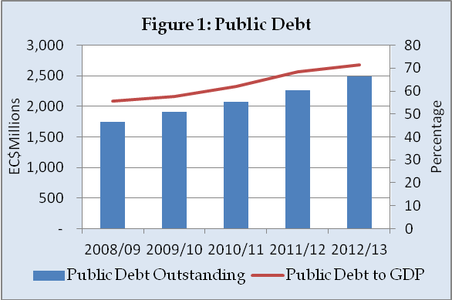At the end of FY2012/2013, the total public debt stood at $2,551.19 million of which central government debt totaled $2,384.66 million or 95.9 percent. Over the period FY2008/2009 to FY2012/2013, public debt had an average annual increase of 9.2 percent with the debt/GDP increasing from 55.7 percent in 2008/2009 to 71.4 percent in 2012/2013 as shown in Figure 1.

Government-guaranteed debt of $101.35 million and non-guaranteed debt of $65.18 million represent 3.97 percent and 2.55 percent respectively of public debt. There has been a general decrease in the level of government-guaranteed debt from FY2008 to 2013.

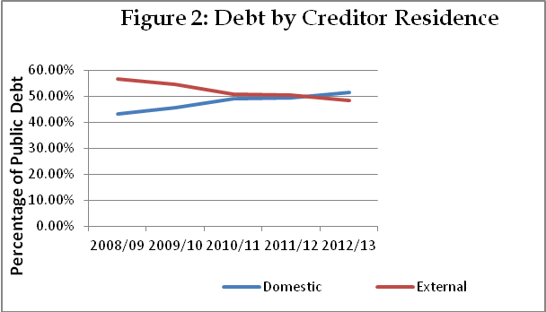The percentage of public debt held by domestic residents continued to increase from FY2008/2009 to 2012/2013 while debt by external residents showed a decline over the same period (Figure 2). This change in the composition of the debt indicates that over the past five years that the RGSM provided favourable conditions for Budget financing.

**CENTRAL GOVERNMENT DEBT PORTFOLIO**

The total central government debt stock at March 31, 2013 stood at $2,384 million or 66.3 percent of GDP, of which domestic debt amounts to $1,242 million or 34.51 percent of GDP and external debt accounts for $1,143 million or 31.73 percent of GDP (Figure 3).

**Domestic Debt Portfolio**

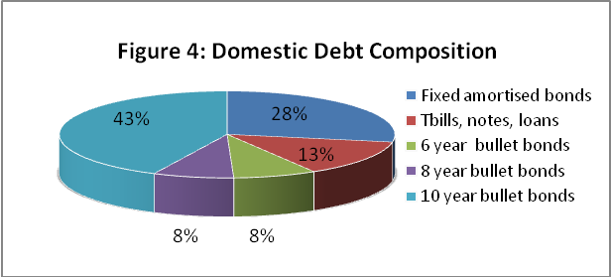The profile of domestic debt has changed from 2004, with the first issuance of instruments on the RGSM. Since then, the government has relied heavily on the RGSM to raise funds for the budget. The RGSM is the main platform for the issuance of bonds, notes, and Treasury bills. Commercial banks and other financial institutions are the major creditors for domestic loans. In addition, private placements exist for Treasury bills and notes through the National Insurance Corporation (NIC), commercial banks, and other financial institutions. In these arrangements, the government gets an opportunity to negotiate with the creditors on more favorable terms. Domestic debt currently stands at 52.09 percent of total central government debt stock. The current domestic portfolio comprises of six, eight and ten year bullet bonds which total $975 million or 58.6 percent of the domestic portfolio, amortized bonds $463 million or 27.8 percent and Treasury Bills, Notes, and loans $225 million or 13.5 percent (Figure 4). The largest component of domestic debt comprises instruments with short to medium term maturities exposing the portfolio to considerable refinancing and roll-over risk.

**External Debt Portfolio**

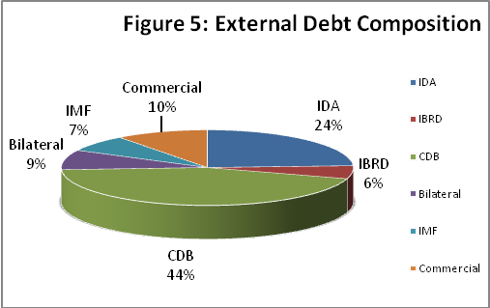External debt accounts for approximately 47.9 percent of total central government debt stock. This reflects recent trends in the availability and access to bi-lateral and multi-lateral concessional funding. Multi-lateral debt accounts for $587 million or 81.3 percent of the total external debt stock while bi-lateral debt accounts for $61 million or 8.5 percent. The bilateral creditors include the Agence Francaise de Development (AFD) and the Kuwait Fund for Arab Economic Development (KFAED). The major multi-lateral creditors include the Caribbean Development Bank (CDB), accounting for $320 million or 27.98 percent of the debt, the International Development Association (IDA) which accounts for $153.25 million or 24.2 percent, the IMF, $52 million or 7.2 percent and the International Bank for Reconstruction and Development (IBRD) accounting for $40 million or 5.5 percent of the total external debt stock (Figure 5).

**External Debt Currency Composition**

At March 31, 2013, US dollar debt accounted for 64 percent of the external debt portfolio totaling $423.4 million. Special Drawing Rights (SDR) accounted for 27 percent which totals $175 million with Kuwaiti dinars and Euros 5 percent and 4 percent respectively (Figure 6).

**External Debt Interest Rate Comparison**

The proportion of external debt contracted with variable interest rates is relatively low because the Government of St. Lucia has reduced its exposure to interest rate risk ensuring that new debt is contracted with fixed interest. Variable interest rates accounted for 35 percent totaling $230 million while fixed interest rates accounted for 65 percent or $429 million of the external portfolio (Figure 7).

**Investor Composition of RGSM Debt**

At March 31, 2013, St. Lucia’s RSGM debt was varied widely. Financial institutions comprised the greatest share of 44 percent totaling over $413 million, followed by commercial banks and social security with 19 percent each. Combined, they total over $359 million. Insurance companies account for 14 percent or approximately $132 million. Private individuals, the ECCB and other uncategorized firms combine to share $40 million or 4 percent of the RGSM debt (Figure 8).

**Central Government Debt Maturity Profile**

The maturity profile of the central government is skewed toward the short to medium term with 7 percent of the central government’s debt maturing within one year in the sum of EC$413 million, and 30.7 percent or EC$1,716 million maturing within 2 to five years. Most of the debt held by domestic investors and is composed primarily of government securities and carries fixed interest rates. Debt maturing in the long term or 5 years and beyond is approximately 61 percent of the total stock of debt or EC$3,458 million (Figure 9).

### Cost and Risk

|  |  |  |
| --- | --- | --- |
| **Table 1: Risk Indicators** |  | **Total debt** |
| Amount (in millions of USD) |  | 883.5 |
| Nominal debt as % GDP |  | 66.3 |
| PV as % of GDP |  | 61.8 |
| Cost of debt | Weighted Av. IR (%) | 5.6 |
| **Refinancing risk** | ATM (years) | 5.7 |
| Debt maturing in 1yr (% of total) | 17.8 |
| **Interest rate risk** | ATR (years) | 5.0 |
| Debt refixing in 1yr (% of total) | 26.9 |
| Fixed rate debt (% of total) | 90.1 |
| **FX risk** | FX debt (% of total debt) | 31.1 |
| ST FX debt (% of reserves) | 6.7 |

In terms of interest rate exposure, the average time to re-fixing (ATR) is 5 years in the current portfolio due mainly to the proportion of fixed rate instruments (Table 1). Average time to re-fixing (ATR) is a measure of the weighted average time until all principal payments in the debt portfolio become subject to a new interest rate. A shortening of this indicator suggests that the portfolio is on average facing a new interest rate more frequently and therefore is more exposed to refixing shocks.

A 9.9 % share of variable rate debt assumes mimimal exposure of the portfolio to debt refixing. The variable rate instruments in the portfolio can be accounted for by CDB Ordinary Capital Resources (OCR) which re-fixes every 6 months and the IBRD portion of World Bank loans which uses LIBOR rates and re-fixes between 1 and 6 months. Although these rates are variable, the WACD is 2.2 % given that the instruments are obtained on concessional terms.

The average time to maturity (ATM) of the total central government debt portfolio is 5.7 years (Table1). During the next financial year, 2013/2014, 17.28 percent ($412m) is set to mature while over the medium term or next two to five years, 34.19 percent ($815m) is due for principal repayment. Debt maturing in six years or greater amounts to $1157m (48.53 percent).

Currency risk is minimal within the portfolio given that US dollar denominated debt accounts for 64 percent of external debt and the EC dollar is pegged to the US dollar. About 10.37 percent of the central government debt falls within the category of non US and non ECD. It is not envisaged that there will be any change in this current policy amongst the ECCU member countries in the near future and so currency risk does not pose a significant threat to the portfolio.

# 

# SECTION 6

# MACROECONOMIC OVERVIEW

Preliminary indications suggest that the Saint Lucia economy continued to experience weak economic activity during 2013. Real GDP growth is estimated to contract by 0.4 percent in 2013 based on preliminary data for the period January to September. The positive gains realized from the recovery in the tourism and agriculture sectors are expected to be offset by declines in the manufacturing and banking and insurance sectors. Consumer prices is projected to edge upwards to 3.8 percent in 2013 from the 4.2 percent recorded in 2012 partly due to the implementation of VAT in October last year. The rate of unemployment is expected to remain elevated in 2013.

**Table 2: Summary of Central Government Fiscal Operations**



Owing to government’s fiscal consolidation efforts outlined in the 2013/14 budget statement, the fiscal deficit experienced in 2012/13 is projected to improve to $295.5 million or 7.8 percent of GDP at the end of the 2013/14 fiscal year compared with the revised deficit of $340.1 million or 9.5 percent of GDP recorded in the fiscal year 2012/13. This reflects a projected increase in total revenue and grants by 11.0 percent to $957.2 million mainly due to higher VAT receipts. Total expenditure however is estimated at $1,224.3 million, compared to $1173.2 in 2012/13. The increase in salaries and wages coupled with the rise in interest payments will result in an increase in current expenditure of $877.3 million from $856.9 million in 2012/13. This will result in an improvement in the current account balance from a deficit of $56.7 million in 2012/13 to $43.3.3 million in 2013/14. Notwithstanding the increases in the interest payments, the primary balance is estimated to move from a deficit of $217.0 or 6.0 percent of GDP to $154.2 million or 4.1 percent of GDP as shown in Table 2.

The stock of total public debt is estimated at $2,823 million at the end 2013/14 relative to $2,384.6 million recorded in 2012/2013. As a ratio of GDP, total public debt is estimated at 76.8 percent at the end of 2013/14 from 71.1 percent in 2012/13.

**Macro-Economic Outlook**

According to World Economic Outlook projections the world economy is expected to grow by 2.9 percent in 2013 and 3.6 in 2014 with gradual upturns in advanced, emerging and developing economies however down side risks remain high. Domestically growth is expected to remain subdued over the medium term despites governments’ best effort at promoting economic growth and restoring macroeconomic stability. While the domestic economy is expected to benefit from the positive developments in the global economic climate, the high unemployment rate coupled with weak demand and competiveness of the economy are expected to offset these gains.

The projected growth in the United States and United Kingdom which are the key tourism source markets are expected to have a positive impact on the tourism sector. Continued efforts in improving airlift and marketing are expected to positively impact the industry and have positive spin offs on the islands transport and restaurant sectors.

The agricultural sector is expected to contribute positively to output as the recovery in the banana sector continues. However this recovery is contingent on the management of pests and diseases and the restoration of farmers’ confidence in the sector as well as favorable weather conditions. The growth in the sector will be supported by the completion of the Meat Processing Plant and the increase in the domestic guarantee market share for broiler production. The operationalization of the clearing house and the continued efforts directed at crop diversification is expected to impact the sector positively.

Activity in the construction sector is expected to improve as the momentum from the construction stimulus package takes root leading to increase private construction activity. The commencement of some major tourism related projects is expected to restore construction activity in the private sector.

During the medium term the Government is expected to continue implementing fiscal reform measures which should result in further improvement in its fiscal operations. Improvement in revenue administration, prudent selection of the capital projects and well as expenditure curtailing measures are all expected to result in a better overall fiscal position.

**Risk factors**

Notwithstanding the best efforts aimed at reversing the fiscal slide and restoring debt sustainability, the negative headwinds emanating from the external environment could offset whatever gains are achieved on the fiscal front. The forecast therefore is contingent on a gradual improvement in the global economy and the successful and timely implementation of fiscal consolidation measures. The high level of unemployment, uncompetitiveness of the economy and weak domestic demand represent serious challenges that government’s fiscal policy needs to respond to, and therefore could counteract the best efforts at fiscal consolidation.

**SECTION 7**

**MEDIUM TERM DEBT MANAGEMENT STRATEGY**

**Pricing Assumptions**

The pricing assumptions are based on current market sentiments. Illustrated in table 3 are the cost and maturity structure for each of the different creditor category used is in formulating the alternative strategies.

**Table 3: Pricing Assumptions**

|  |  |  |  |  |
| --- | --- | --- | --- | --- |
| **Creditor Category** | **Interest Type** | **Interest Rate (%)** | **Grace Period (years)** | **Maturity (Years)** |
| Multilateral | Fixed | 0.75 – 2.00 | 10 | 40 |
| Multilateral | Variable | 2.50 margin | 5 | 15 |
| Multilateral (SDR) | Fixed | 0.50 | 3 | 15 |
| Bilateral | Fixed | 3.75 | 4 | 15 |
| International Capital Market | Fixed | 9.00 | 9 | 10 |
| Commercial | Fixed | 8.25 | 2 | 12 |
| Bonds | Fixed | 6.00 | 9 | 10 |
| Treasury Bill | Fixed | 7.20 | 0 | 1 |

**Potential Financing Sources**

## The financing sources available to the Government for the FY 2013/2014 are multilaterals, commercial and the domestic market. However, for the FY2012/2013, funding was sourced from the multilaterals, bi-laterals, commercial and the domestic market. Potential sources of finance for first three years of the preferred strategy will be from traditional sources like the multilateral, bilateral domestic market and commercial creditors. In subsequent years, the concentration of the financing is on the International Capital Market (ICM).

**Description of the strategies**

**Strategy one (S1): Current borrowing practices of government**

This strategy maximises domestic borrowing, assuming that on average 53.0 percent of gross financing needs are met through these sources. The remaining 47.0 percent of gross financing needs will be met through external sources primarily commercial borrowing. This strategy relies heavily on Treasury bills and commercial instruments. On average, $231.50 million will be rolled over in Treasury bills each year while the financing gap in each period will be financed by commercial borrowing averaging $248.1million.

**Strategy two (S2): Reduce the cost of debt through greater concessional funding**

An average of 51.0 percent of the gross financing needs will be met through the domestic market while 49.0 percent from external sources. Domestic funding sources will be primarily fixed 10-year bullet bonds and short term Treasury bills on the RGSM. This strategy assumes a continuous rollover of Treasury bills of approximately $235.5 million each year over the 5 year period as well as rollover of maturing instruments totaling $330.8 million between 2016 and 2018. External sources of funding remain significant in this strategy as funding primarily from bilateral creditors such as Kuwait Fund for Arab Economic Development, European Investment Bank and Groupe Agence Francaise De Development is expected to average $176.0 million each year. Other external sources which would play a part in meeting the gross financing needs under S2 are the CDB, IDA, and IBRD averaging annually $48.0M, $49.0M, and $35.0M respectively over the 5 year period.

**Strategy three (S3): Reduce rollover risk and reliance on short term domestic instruments**

This strategy focuses on reducing the country’s reliance on short term borrowing by converting the RGSM Treasury bills and private placements to longer term instruments. The gross financing needs will be met through the issuance of longer term instruments on the external and domestic markets. It is expected that an average of 52.0 percent of the gross financing will be met externally, mainly through commercial borrowing by the FY 2017/18. The remaining 48.0 percent of gross financing will be funded through the domestic market targeted at 8 year and 10 year instruments to lengthen the maturity profile of the portfolio. This strategy reflects a deviation from current trend by reducing its dependence on short-term instruments from an average of 30.0 percent to 14.0 percent by 2017/18. However, it continues to rely heavily on the domestic market in achieving the objective of lengthening the maturity profile.

**Strategy four (S4): Access the International Capital Market in 2016**

This strategy relies heavily on external borrowing, in particular, issuing bonds on the International Capital Market (ICM) as an alternative to the current strategy. It is envisioned that raising funds on the ICM by FY 2016/2017 will reduce the reliance on the domestic market and particularly the RGSM. This strategy will focus on reducing the concentration of short term securities to longer term instruments and hence mitigate the impact of rollover risks associated with the current strategy (S1). S4 assumes that the dynamics of meeting the gross financing needs will be reversed by 2016/2017 with an average 32.0 percent being sourced from the domestic market and the remaining 68.0 percent from external borrowing, mainly from ICM. It is further assumed that within the first two years of the strategy it will mirror the existing strategy of financing through concessional funding, commercial borrowing and the domestic market to fund capital projects.

The alternative strategies are enshrined in the instruments illustrated in Appendix 3.

**Description of Scenarios**

Consistent with the debt sustainability analysis the strategies were subjected to interest rate and exchange rate shocks under four scenarios:

* Scenario 1: D***epreciation of the domestic currency***. Under this scenario in FY 2014/15 the Eastern Caribbean dollar depreciates by 30% relative to the non-pegged foreign currency (XDR) in the debt portfolio.
* Scenario 2: ***Interest rate shock***. The cost of all variable rate borrowing increases by 100 basis points. This is a permanent shock applied throughout the five year period.
* Scenario 3: ***Interest rate shock***. The cost of all variable rate borrowing increases by 200 basis points. This is a permanent shock applied throughout the five year period.
* Scenario 4: ***This is a combination shock*.** In this scenario the domestic currency depreciates by 10% relative to the non-pegged foreign currency (XDR) and interest rates on variable rate instruments increase by 100 basis points.

Appendix 2 gives the details of each scenario and its impact on various debt vulnerability indicators.

## Cost & Risk Analysis of strategies

An analysis of the risk indicators for the current debt portfolio as well as the alternative debt management strategies are summarized below in Table 4. The main risk associated with the current debt portfolio is the refinancing risk given that the Average Time to Maturity (ATM) is 5.7 years.

**Table 4: Risk Indicators**

|  |  |  |  |  |  |  |  |  |
| --- | --- | --- | --- | --- | --- | --- | --- | --- |
| Risk Indicators |  |  |  | 2013 | As at end FY2018 | |  |  |
|  |  |  |  | Current | S1 | S2 | S3 | S4 |
| Nominal debt as % of GDP |  |  |  | 64.5 | 86.1 | 84.2 | 86.2 | 86.4 |
| PV as % of GDP |  |  |  | 61.8 | 81.9 | 78.7 | 82.1 | 82.6 |
| Implied interest rate (%) |  |  |  | 5.61 | 6.06 | 4.89 | 6.14 | 6.43 |
| Refinancing risk | ATM External Portfolio (years) | | | 9.4 | 8.9 | 10.4 | 8.9 | 9.2 |
|  | ATM Domestic Portfolio (years) | | | 4.2 | 4.2 | 4.0 | 6.2 | 3.6 |
|  | ATM Total Portfolio (years) | | | 5.7 | 6.8 | 7.8 | 7.3 | 7.7 |
| Interest rate risk | ATR (years) |  |  | 5.0 | 6.3 | 6.9 | 6.9 | 7.3 |
|  | Debt refixing in 1yr (% of total) | | | 26.9 | 24.2 | 28.8 | 20.6 | 16.9 |
|  | Fixed rate debt (% of total) |  |  | 90.1 | 91.9 | 85.6 | 91.4 | 93.2 |
| FX risk | FX debt as % of total | |  | 28.4 | 55.9 | 58.9 | 55.1 | 73.4 |
|  | ST FX debt as % of reserves | | | 6.7 | 19.7 | 11.7 | 18.9 | 19.7 |

The ATM of a debt portfolio is an indicator of the weighted average time to maturity of all principal repayments in the debt portfolio. It shows on average how long it takes to rollover the debt portfolio. A shortening of this indicator suggests the portfolio is being rolled over more frequently and is exposed to refinancing risk. Refinancing risk is the risk that debt will have to be rolled over at an unusually high cost or in extreme cases cannot be rolled over at all. The ATM increased from 5.7 years to 7.8 years in S2 since 34.0 percent of its financing comes from the multi-laterals like IDA which have a maturity profile ranging from 25-40 years and grace period ranging 5-10 years.

Average time to re-fixing gives an indication of the exposure of the debt portfolio to changes in interest rates. This indicator averages 6.9 years over S1 to S4, whilst S4 has the longest average time to re-fixing of 7.3 years reflective of the high level of fixed rate instruments of 93.2 percent. Furthermore, it indicates that under S4 the average time until interest rate is subject to reset is 7.3years.

The foreign debt as a percentage of total debt in the portfolio is 73.4 percent for S4 which is the highest among the alternative strategies. Although S4 accounts for greatest share of foreign exchange debt most of its instruments are in US dollar which means S4 is buffered from currency risks since the EC dollar is pegged to the US dollar. However, S2 has the highest level of FX risk mainly because its currency composition is more skewed to non US dollar debt or volatile currencies such as the Special Drawings Rights (XDR).

The cost/risk makeup of the individual strategies is shown below (Figure 11). The cost and risk examined under the four scenarios relate primarily the debt to GDP, Present Value (PV) of Debt to GDP and interest to GDP indicators. (The risk represents the deviation from the baseline indicator results when interest and exchange rate shocks are applied.) S2 has the lowest debt/GDP ratio but it is most susceptible to interest and exchange rate shocks given the reliance on concessional funding which has variable rate instruments available for these creditors. Therefore, S2 also presents the lowest cost but highest risk for the interest/GDP ratio.

**Figure 11:** **Cost/Risk Indicators of Alternative Debt Strategies**



Over the five year period of the implementation of the MTDS, Strategy 4 (International Capital Market) has the longest ATR of 7.3 with a second highest ATM of 7.7 years while having the highest cost of 6.4 per cent. These characteristics of S4 are attributable to the types of instruments accessed under this strategy mainly the bond to be issued on the international capital market. S4 seem to be the most realistic option for implementation given the types of projects that are expected to be funded and the saturation of the RGSM with GOSL securities.

## Selection of Strategy

### The net new borrowing over the period is influenced by the relative size of the existing debt portfolio. Hence, the characteristics of the current debt portfolio and the strategies will continue to influence the decision of the MTDS. Consequently, the existing portfolio is characterized by short term domestic debt creating significant pressure on cash-flows and prone to high rollover risks. It is expected that the chosen strategy will alleviate this risk in the portfolio.

### Based on the aforementioned, S4 was selected to address the issue of bunching of payments which increases the rollover risk in the portfolio. Illustrated in Figure 1 of the appendix are the strategies’ amortization schedules. Lengthening the ATM from 5.7 years to 7.7 years is critical to mitigating roll-over risk. Seventy-four percent of the instruments used are long term ranging from 8-40 years which account for the increase of the ATM. The strategy attempts to refinance a significant portion of the short term instruments in the period of overview. The stock of treasury bills will shift from EC$231.5 million to EC$35 million by 2018.

### Further to increasing the ATM, S4’s objective is to reduce the heavy reliance on the domestic market. In prior years, the RGSM has been used as the main source for financing the Budget. However, there is a need to diversify the investor base of the portfolio beyond the region. In this FY 2013/2014 it is the intention to obtain 38.0 percent of the funds from the external market through commercial borrowings. It means that in this FY there is a gradual shift from the domestic market to the external market. This trend will continue until 2016. However by 2017, a greater percentage of the borrowing will be sourced from the external markets.

One of the factors that would determine the feasibility of S4 is a favourable international credit rating which is dependent on required macroeconomic and fiscal indicators of the country, the political climate, quality of statistics, effectiveness of public financial management and expenditure controls before the ICM is accessed. Weak vital indicators and transparency can result in a poor credit rating and higher prices for any issue by the country. Recently, the government was given a *BBB* rating[1] for three of its bond issues during the fiscal years of 2011 to 2013.

# SECTION 8

# IMPLEMENTATION METHODOLOGY

# Annual Borrowing Plan

An Annual Borrowing Plan (ABP) will be prepared to accompany the Medium Term Debt Strategy and will be congruent with Estimates of Expenditure and Revenue Estimates for the financial year 2013/2014. The projected gross financing needs for the year stand at $697.25 million. The Annual Borrowing Plan will implement the operational target extolled by the MTDS S4 with an average of 68 percent external funding and 32.0 percent domestic financing as Table 5 depicts.

**Table 5: Annual Borrowing Plan**

|  |  |  |  |  |  |
| --- | --- | --- | --- | --- | --- |
| **Annual Borrowing Plan under Strategy 4 (Millions of ECD)** | | | |  |  |
|  | **2013/2014** | **2014/2015** | **2015/2016** | **2016/2017** | **2017/2018** |
| **Domestic** | 387.95 | 361.04 | 377.27 | 30.00 | 35.00 |
| **External** | 309.30 | 420.83 | 393.62 | 800.02 | 600.92 |
| Total Gross Financing | 697.25 | 781.87 | 770.89 | 830.02 | 635.92 |

It is expected that the existing strategy of the Government will continue as is over the first three years from FY2014 to FY2016. Subsequently, the operational target will be met using primarily funds sourced from the International Capital Market. Eighty six percent (86.0%) and ninety-three (93.0%) of the funds are expected to be sourced from the International Capital Market in FY2017 and 2018 respectively. Consistent with the preferred strategy and working on mitigating the impact of rollover risks associated with the current strategy, approximately one percent (1.0%) the financing needs of the government will be met with Treasury Bills in the domestic market in the last two years of the MTDS implementation period.

The GOSL continues to maintain transparency and predictability of debt issuance by publishing schedules of upcoming maturing and new instruments through its annual prospectus and calendar as shown in Table 6.

**Table 6: Calendar of Issues of Existing Securities**

|  |  |  |  |  |  |
| --- | --- | --- | --- | --- | --- |
| **Auction Date** | **Instrument Type** | **Issue Amount** | **Maximum Rate (%)** | **Maturity Date** | **Trading Symbol** |
| 17th October 2013 | 6-yr Bond | ECD40.0M | 7.00 | 18th October 2019 | LCB061019 |
| 29th October | 91-day T-Bill | EC$16.0M | 6.00 | 29th January 2014 | LCB290114 |
| 7th November 2013 | 91-day T-Bill | EC$11.0M | 6.00 | 7th February 2014 | LCB070214 |
|  |  |  |  |  |  |
| 20th January 2014 | 180-day T-Bill | EC$25.0M | 6.00 | 20th July 2014 | LCB200714 |
| 30th January 2014 | 91-day T-Bill | EC$16.0M | 6.00 | 2nd May 2014 | LCB020514 |
| 10th February 2014 | 91-day T-Bill | EC$11.0M | 6.00 | 13th May 2014 | LCB130514 |
|  |  |  |  |  |  |
| 6th May 2014 | 91-day T-Bill | EC$16.0M | 6.00 | 6th August 2014 | LCB060814 |
| 14th May 2014 | 91-day T-Bill | EC$11.0M | 6.00 | 14th August 2014 | LCB140814 |

## IMPLEMENTATION AND MONITORING

The document will be submitted to Cabinet for transmission to Parliament to obtain its approval. However, the DIU at the Department of Finance remains the focal point in developing a comprehensive medium-term debt management strategy for the government. The DIU is responsible for regularly updating the strategy and monitoring all borrowings to ensure that they are within the stipulated guidelines and risk parameters of the strategy. A detailed borrowing plan will accompany the implementation and monitoring plan.

The DIU will engage in quarterly updates of the MTDS with annual reviews in collaboration with the Research and Policy Unit and ECCB (DMAS). The annual revisions to the MTDS should be submitted to Cabinet in preparation for the annual Budget Cycle.

# 

# SECTION 9

# TRANSPARENCY AND ACCOUNTABILTY

Pursuant to section 16 of the Finance (Administration) Act Cap. 15.01, on the last day of the Financial Year a statement of Public Debt and Contingent Liabilities has to be submitted to the Accountant General for compiling the Public Accounts.

# SECTION 10

# ACKNOWLEDGEMENT

The Department of Finance would like to thank the Canada-Eastern Caribbean Debt Management Advisory Service for their continued support in providing training and technical assistance in the preparation of Saint Lucia’s first formal Medium Term Debt Management Strategy.

The inaugural Medium Term Debt Management Strategy has been formulated on the premise of the prudent contraction of debt taking into account the cost and risk consequences. The proceeds of the debt are to support expenditure in priority areas that will promote economic growth and reduce poverty over the long term.

Overall, the Government of Saint Lucia has placed emphasis on accessing external concessionary debt to achieve its objective of minimizing cost. However, given that these sources may not be forthcoming mainly because conditions precedent to first disbursement are not being met, the Government has sought to diversify its sources of financing through greater focus on obtaining its financing needs on the RGSM. Accessing the domestic market beyond the RGSM may also pose a challenge given a limited liquidity environment and associated risk of crowding out the private sector.

The development and implementation of an MTDS require skilled and committed human resources. Against this back-drop, I wish to thank the Debt Management Advisory Services for the invaluable effort extended to the staff in the Department of Finance through capacity building programs of this nature. Similarly, the Government will continue to partner with other institutions which promote capacity building in financial management in the public sector.

The 2013 Medium Term Debt Management Strategy has been prepared collaboratively by the staff of the Debt and Investment Management Unit, Research and Policy Unit and Accountant General’s Department in consultation with the Eastern Caribbean Central Bank under the DMAS Project. I wish to express sincere gratitude to the core team involved in its preparation.

**SECTION 11**

**GLOSSARY**

**Amortized Bonds**

Amortized Bonds are debt instruments with a maturity of more than five years which are paid off in regular installments over a specific period of time.

**Average time to maturity (ATM)**

ATM is an indicator of rollover risk which measures how long it takes on average to rollover the debt portfolio.

**Average time to re-fixing (ATR)**

ATR is an indicator of interest rate risk which measures the weighted average time until all principal repayments in the debt portfolio become subject to a new interest rate.

**Bullet Bonds**

A bullet bond is a debt instrument whose entire nominal value is paid at once on the maturity date of the bond issued.

**Caribbean Development Bank Ordinary Capital Resources (CDB OCR)**

Caribbean Development Bank Ordinary Capital Resources is a financial resource of the Bank which comprises mainly of subscribed capital and borrowings and is on non-concessional terms to Borrowing Member Countries (BMCs).

**Concessional Debt**

A concessional debt is a debt with a grant element of 25 percent or above, using a discount rate of 10 percent. These are similar to “soft financing” which carries a below-market rate of interest, and longer maturities than conventional banks, and is usually made by multinational development banks such as the IMF, World Bank or CDB.

**Credit Rating**

A credit rating represents the credit worthiness for a government evaluated by a credit rating agency to assess the likelihood of default. The credit ratings of the Government of Saint Lucia by CariCRIS have been assigned a notional rating which is a bond specific rating for the government’s bond issues.

**Currency Risk**

Currency risk or foreign exchange rate risk relates to the vulnerability of the debt portfolio and the government’s debt costs to a depreciation or devaluation in the external value of the domestic currency.

**Debt Service Payments**

Debt service payments refer to the repayment of interest and principal charges on a debt. These payments may also include service charges or commitment fees which may be attached to a loan.

**LIBOR**

LIBOR stands for London Interbank Offered Rate. LIBOR is derived from a filtered average of the world’s most creditworthy banks interbank deposit rates for larger loans with maturities between overnight and one full year.

**Maturity Profile**

A graphical picture of when the outstanding obligations of the government will become due.

**Monetary Council**

This refers to the highest decision-making authority of the Eastern Caribbean Central bank and comprises of eight ministers from each of the participating governments.

**Prospectus**

A prospectus is a document which provides information that an investor needs to make an informed investment decision regarding the instrument offerings of the Government.

**Public Debt**

Public Debt refers to the obligations of Central Government.

**Refinancing/Rollover Risk**

Refinancing Risk is an indicator of the exposure of the debt portfolio to unusually higher interest rates at the point at which debt is being refinanced.

**RGSM**

RGSM refers to Regional Government Securities Market. This is a market where government securities are traded on the Eastern Caribbean Securities Exchange (ECSE), with the aim of reducing the cost of borrowing for the member governments of the eastern Caribbean currency union.

**Sinking Fund**

Sinking fund refers to a provision whereby the government sets aside an amount of money to invest in the repayment of the principal due on an outstanding bond issue or issues.

**Special Drawing Rights (SDR)**

SDR is an international type of monetary reserve currency created by the IMF which operates as a supplement to the standard reserve currencies of member countries.

**Treasury Bills**

Treasury bills are discounted short term instruments up to one year which provide government with financing for liquidity management.

**Treasury Notes**

Treasury Notes are medium term instruments of up to five years which provide financing for government to meet its cash needs.

**Weighted Average Cost of Debt (WACD)**

WACD is the average cost of all debt components of the government which includes the average cost of bonds, treasury bills and loans.

# APPENDICES

## MTDS TABLES

**Appendix 1: Instrument Details**



**Appendix 2: Shock Scenario Analysis of Alternative Strategies**

|  |  |  |  |  |  |
| --- | --- | --- | --- | --- | --- |
| **Debt Stock to GDP ratio as at end 2018** |  |  |  |  |  |
|  |  |  |  |  |  |
| Scenarios |  | S1 | S2 | S3 | S4 |
| Baseline |  | 86.1 | 84.2 | 86.2 | 86.4 |
| Exchange rate shock (15%) |  | 89.7 | 87.9 | 89.9 | 90.0 |
| Interest rate shock 1 ([1% increase in baseline]) | | 86.3 | 84.6 | 86.5 | 86.6 |
| Interest rate shock 1 ([2% increase (similar to shock in DSA)]) | | 86.6 | 84.9 | 86.7 | 86.8 |
| Combined shock (10% depreciation and interest rate shock 1) | | 88.8 | 87.0 | 88.9 | 89.1 |
| Max Risk |  | 3.7 | 3.6 | 3.7 | 3.7 |
|  |  |  |  |  |  |
| **Interest Payments to GDP Ratio as at end 2018** | |  |  |  |  |
|  |  |  |  |  |  |
| Scenarios |  | S1 | S2 | S3 | S4 |
| Baseline |  | 4.7 | 3.8 | 4.8 | 5.0 |
| Exchange rate shock (15%) |  | 4.9 | 3.9 | 5.0 | 5.2 |
| Interest rate shock 1 ([1% increase in baseline]) | | 4.8 | 3.9 | 4.9 | 5.1 |
| Interest rate shock 1 ([2% increase (similar to shock in DSA)]) | | 4.9 | 4.0 | 5.0 | 5.2 |
| Combined shock (10% depreciation and interest rate shock 1) | | 4.9 | 4.0 | 5.0 | 5.2 |
| Max Risk |  | 0.19 | 0.24 | 0.19 | 0.20 |
|  |  |  |  |  |  |
| **PV of Debt to GDP Ratio as at end 2018** |  |  |  |  |  |
|  |  |  |  |  |  |
| Scenarios |  | S1 | S2 | S3 | S4 |
| Baseline |  | 81.9 | 78.7 | 82.1 | 82.6 |
| Exchange rate shock (15%) |  | 85.2 | 82.0 | 85.4 | 86.0 |
| Interest rate shock 1 ([1% increase in baseline]) | | 82.2 | 79.1 | 82.4 | 82.9 |
| Interest rate shock 1 ([2% increase (similar to shock in DSA)]) | | 82.5 | 79.6 | 82.7 | 83.2 |
| Combined shock (10% depreciation and interest rate shock 1) | | 84.4 | 81.3 | 84.6 | 85.2 |
| Max Risk |  | 3.37 | 3.30 | 3.37 | 3.39 |

**Appendix 3: Projected Gross Borrowing**

|  |  |  |  |  |  |
| --- | --- | --- | --- | --- | --- |
| % of gross borrowing - Over Projection Period | | | | | |
| New debt |  | S1 | S2 | S3 | S4 |
| IDA_XDR | FX | 5% | 6% | 5% | 4% |
| IBRD Variable | FX | 1% | 5% | 1% | 0% |
| CDB Variable | FX | 4% | 6% | 5% | 4% |
| Multi – SDR | FX | 0% | 0% | 0% | 0% |
| CDB Fixed | FX | 6% | 6% | 6% | 5% |
| Bilateral | FX | 0% | 18% | 0% | 0% |
| Int'l Capital Market | FX | 0% | 0% | 0% | 34% |
| Commercial | FX | 32% | 7% | 35% | 21% |
| TBills | DX | 30% | 31% | 14% | 20% |
| Bullet_6Yr | DX | 2% | 4% | 2% | 1% |
| Amort_6Yr | DX | 5% | 5% | 3% | 4% |
| Bullet_8Yr | DX | 4% | 3% | 7% | 3% |
| Amort_8yr | DX | 3% | 0% | 7% | 0% |
| Bullet_10yr | DX | 8% | 7% | 9% | 3% |
| Amort_10yr | DX | 3% | 2% | 5% | 0% |
| **External** |  | 47% | 49% | 52% | 68% |
| **Domestic** |  | 53% | 51% | 48% | 32% |
|  |  | **100%** | **100%** | **100%** | **100%** |

**Figure 1: Redemption Profile of Debt under Alternative Strategies**

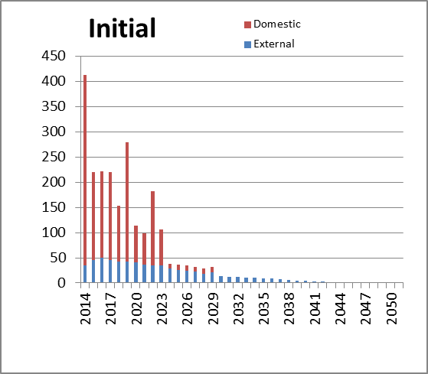

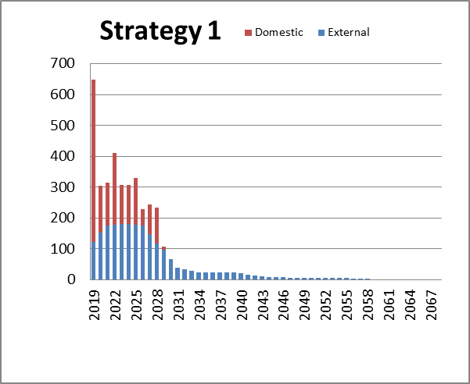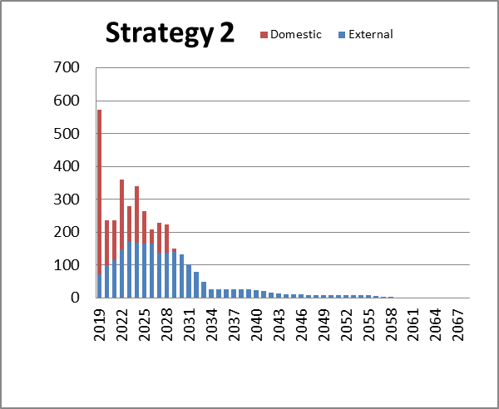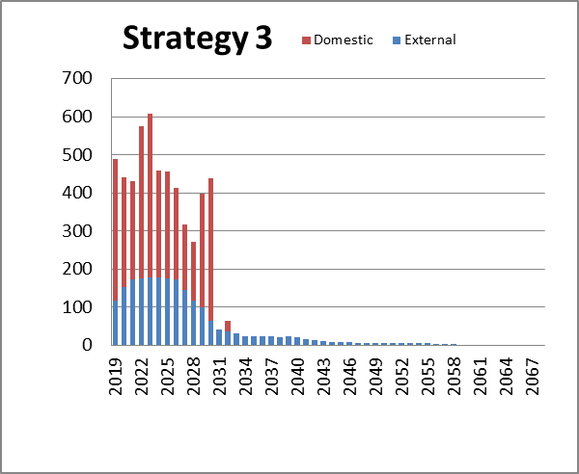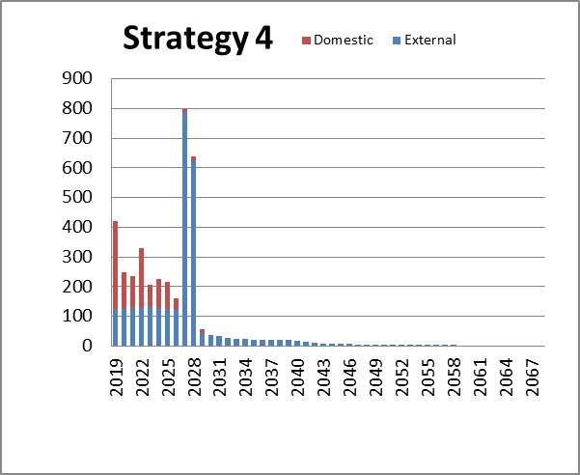

1. This rating was assigned by CariCRIS, Caribbean Information and Credit Rating Services Limited. CariCRIS is the Caribbean’s regional credit rating agency whose aim is to foster and support the development of regional debt markets in the Caribbean. This rating of BBB+ is for the notional amounts of ECD140 million bond issue issued in 2012 as well as for two other bond issues of US50 million and USD38 million issued by the Government of Saint Lucia in 2012 and 2008 respectively.